# Current Activities

## 129 Card Punch / Verifier

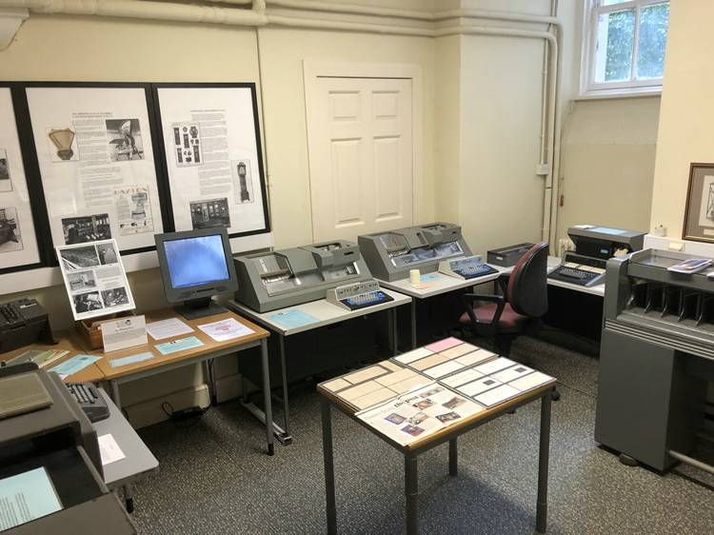The 129 card punch / verifier has now been repaired and is out on display in the Punch Card room. After a full clean and lubrication of the mechanical components, all logic cards and connectors were re-seated. It then powered up and operated normally.

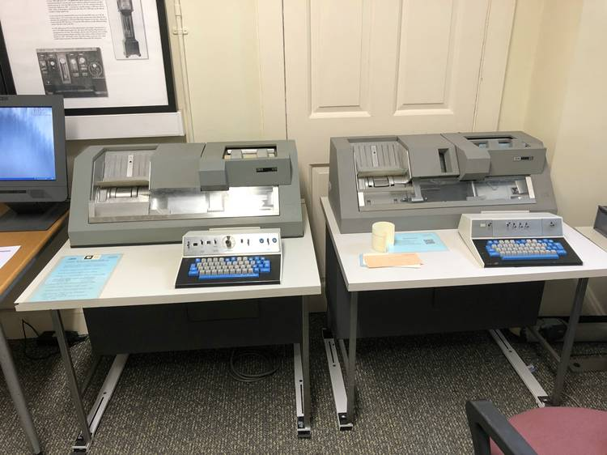

We now therefore have on display the very first card punch used for data processing, the pantograph punch of 1889, and the last IBM card punches, the 129 (1971) for 80 column cards and 5496 (1969) for 96 column cards. The 129 is shown alongside the 029 of 1964.

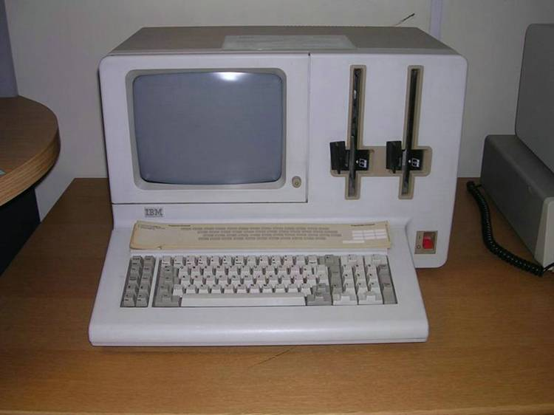We have also had a look at the System/23 Datamaster, General Systems’ Division personal computer. This was announced a little earlier than the IBM PC, with built in CRT display and two 8” floppy drives.

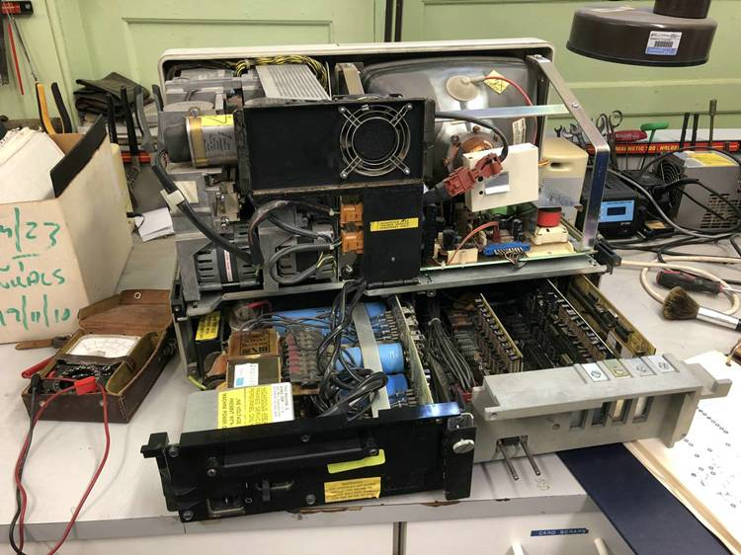So far it has resisted any attempt at life. As is often the case with older hardware, the power supply appears to be the culprit. There are however no obvious signs and we don’t have a wiring diagram, so it seems unlikely we’ll make much progress in the shorter term.

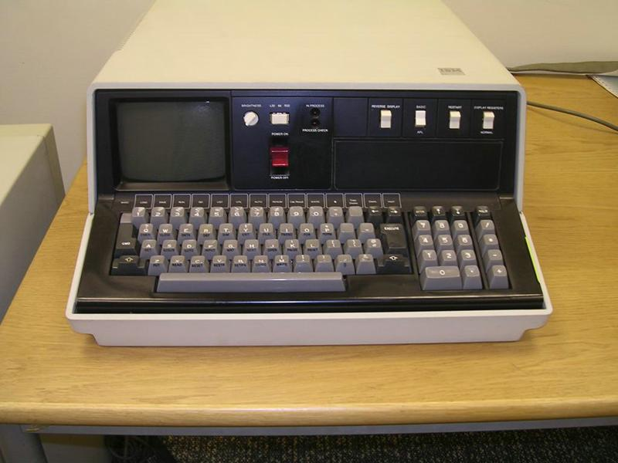Another machine to have received attention in the last month was one of our two 5110 Desktop Computers from 1978. This was IBM’s first all-in-one machine, with a small CRT display and able to run Basic or APL.

On first power up, the display showed a test pattern, but there was no reaction from any keys or switches. Shortly afterwards the main fuse blew, and on replacement the machine would no longer power up. Another power supply...

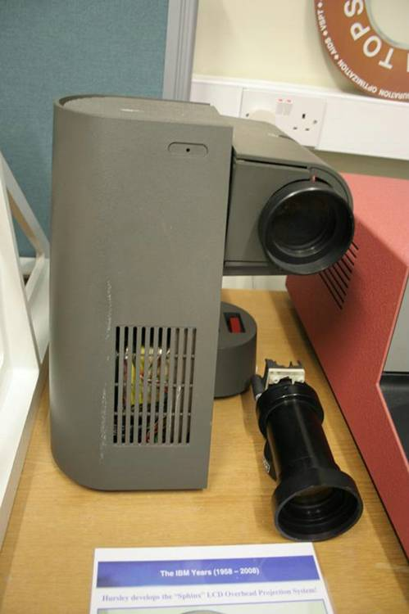

We have also taken a look at the Sphinx LCD Projector. This 1986 development project looked at producing a projector using LCD technology, but was never announced. Our first move was to connect it to its special adapter card in a PC, the projector bulb lit and projected a blank screen on the wall. With help from contacts in Hursley, one of the original development team, now a retiree, came in to see if he could help. Without software we could not produce a signal, and the expert did say it was unlikely the LCD module would still work after 37 years due to chemical deterioration. However he does think there is a way of forcing an image onto the wall, and we await developments.

Finally, we have published another tri-fold, Punch Card Processing, showing various unit record machines and how they fitted into the process. You can download a copy at

<https://slx-online.biz/hursley/docs/pcprocess%20trifold.pdf>